**Project Design Phase-I**

**Proposed Solution Fit and Architecture**

|  |  |
| --- | --- |
| Date | 23th September 2022 |
| Team ID | PNT2022TMID23529 |
| Project Name | IOT Based Smart Farming |
| Maximum Marks | 2 Marks |

**SOLUTION ARCHITECTURE**

**STEP 1:** When the temperature of the soil is increased, the temperature sensor will detect the temperature and water is passed to the land.

**STEP 2:** The water is passed to the land by the help of sprinkler, the sprinkler will sprinkle the water to the land. Moisture level- threshold set  is between 20% and 60%.

Turn ON at 20%.

Turn OFF at 60%.

**STEP 3**: When there any disturbance caused by any living being, the PIR sensor will detect it and intimate the farmer by means of alarm.

**STEP 4**: The plants growth can be monitored by the camera. The camera will send the pic and there is an app implemented in system ,that will detect the plants nutrition level.

Nutrition level of nitrogen is 2-10ppm.

Nutrition level of phosphorous is 25-50ppm.

Nutrition level of potassium is 40-80 ppm.

**STEP 5**: The moisture level in the soil is detected by the humidity sensor.

**STEP 6**: The water level in the tank is detected by the controller.

**STEP 7**: The water pump will pump the water from ground tank to the surface tank.

**STEP 8**: The farmer will monitor the soil fertility and other activities by means of internet connection with a computer.

**STEP 9**: The water is stored at surface used for the present generation.

**STEP 10**: The water stored at the underground is used for the future

use.

**SOLUTION ARCHITECTURE DIAGRAM**

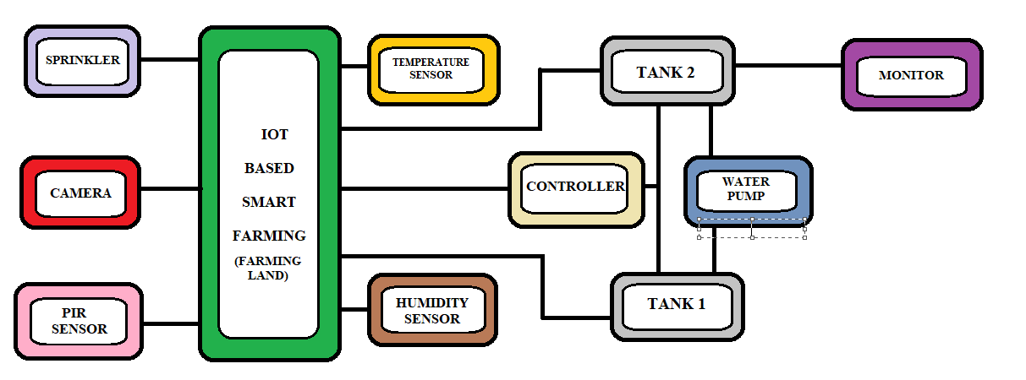

***BLOCK DIAGRAM OF IOT BASED SMART FARMING***